ProjectMASA#2 Opening Night-10.14.06.-16:30hrs.

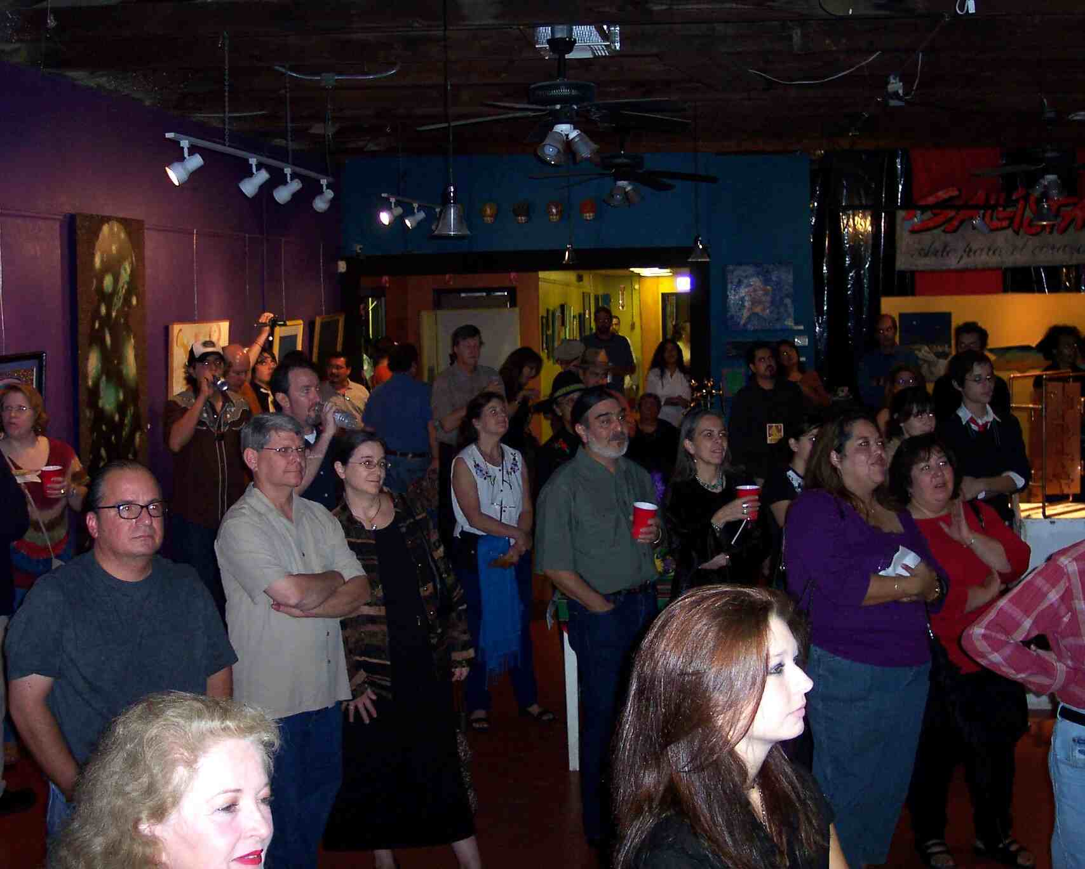
Crowd @ Gallista watching Odyssey One

There was a steady flow of visitors to the exhibit that had been coming in since mid-week. The sixth annual conference of The National Association of Latino Arts and Culture <http://www.siteground133.com/~nalac/index.php?option=com_frontpage&Itemid=1> was held in San Antonio this year from October 11-15 and Project:M.A.S.A. got some national attention by being included in this year’s catalog and itinerary of events. On Friday afternoon a charter busload of visitors from the conference arrived and they previewed the exhibit. We received very positive feedback from all the raza that visited with us that afternoon. Some came back the next evening for the official exhibit opening. The buzz around town about the show had already been picking up and it was the place to be on Saturday night-SA Current <http://sacurrent.com/site/news.cfm?newsid=17339764>, http://sacurrent.com/site/news.cfm?newsid=17339764&BRD=2318&PAG=461&dept_id=550942&rfi=6 UTSA-Today < http://www.utsa.edu/today/2006/10/masa.cfm> .

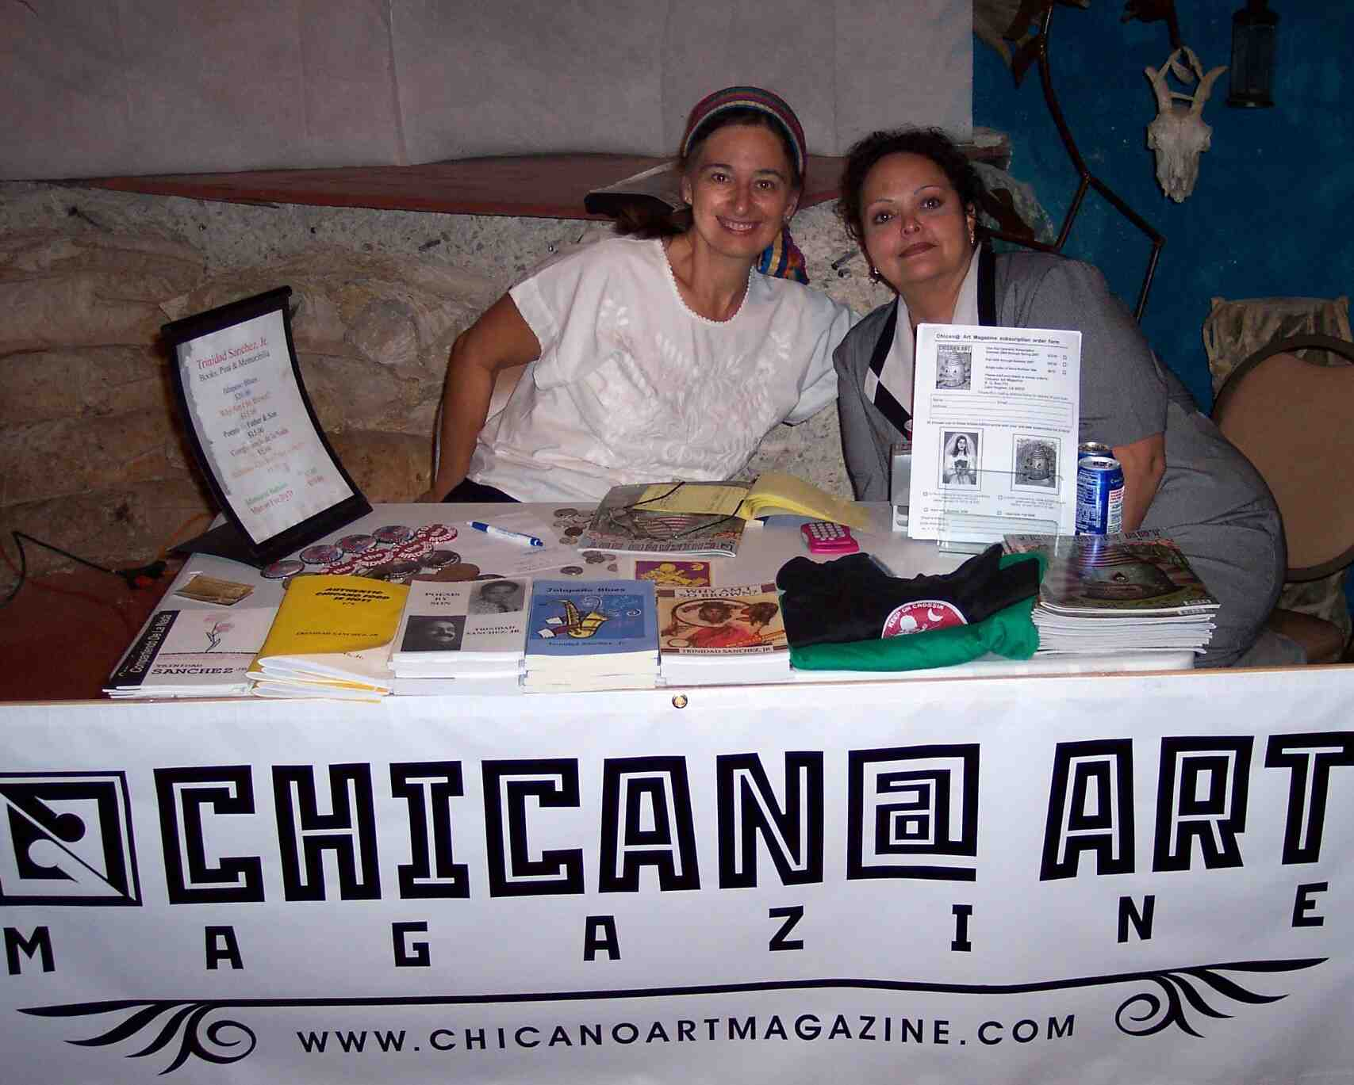
Cynthia Spielman and Regina Chavez y Sanchez volunteer for Chican@ Art Magazine

Opening night was amazing and well attended at Gallista Gallery <http://www.gallista.com/> . Not only did it begin with a thunderous down pour of rain, which didn’t stop the crowd from pouring in the same way, but it was also coincided by the screening of Odyssey-One: Chicanos in Outer Space, a 15min short by writer David Rice <http://www.david-rice.com/index.html>. The short played every hour for new visitors to watch on the big screen. The benefit for Chicano poet Trinidad Sanchez Jr. who passed away in mid August this year culminated and lottery drawings for various donated items by major San Antonio artists, and writers were conducted. Listen to Trino on Texas Public Radio (just scroll down to his name) <http://www.tpr.org/programs/news.html>
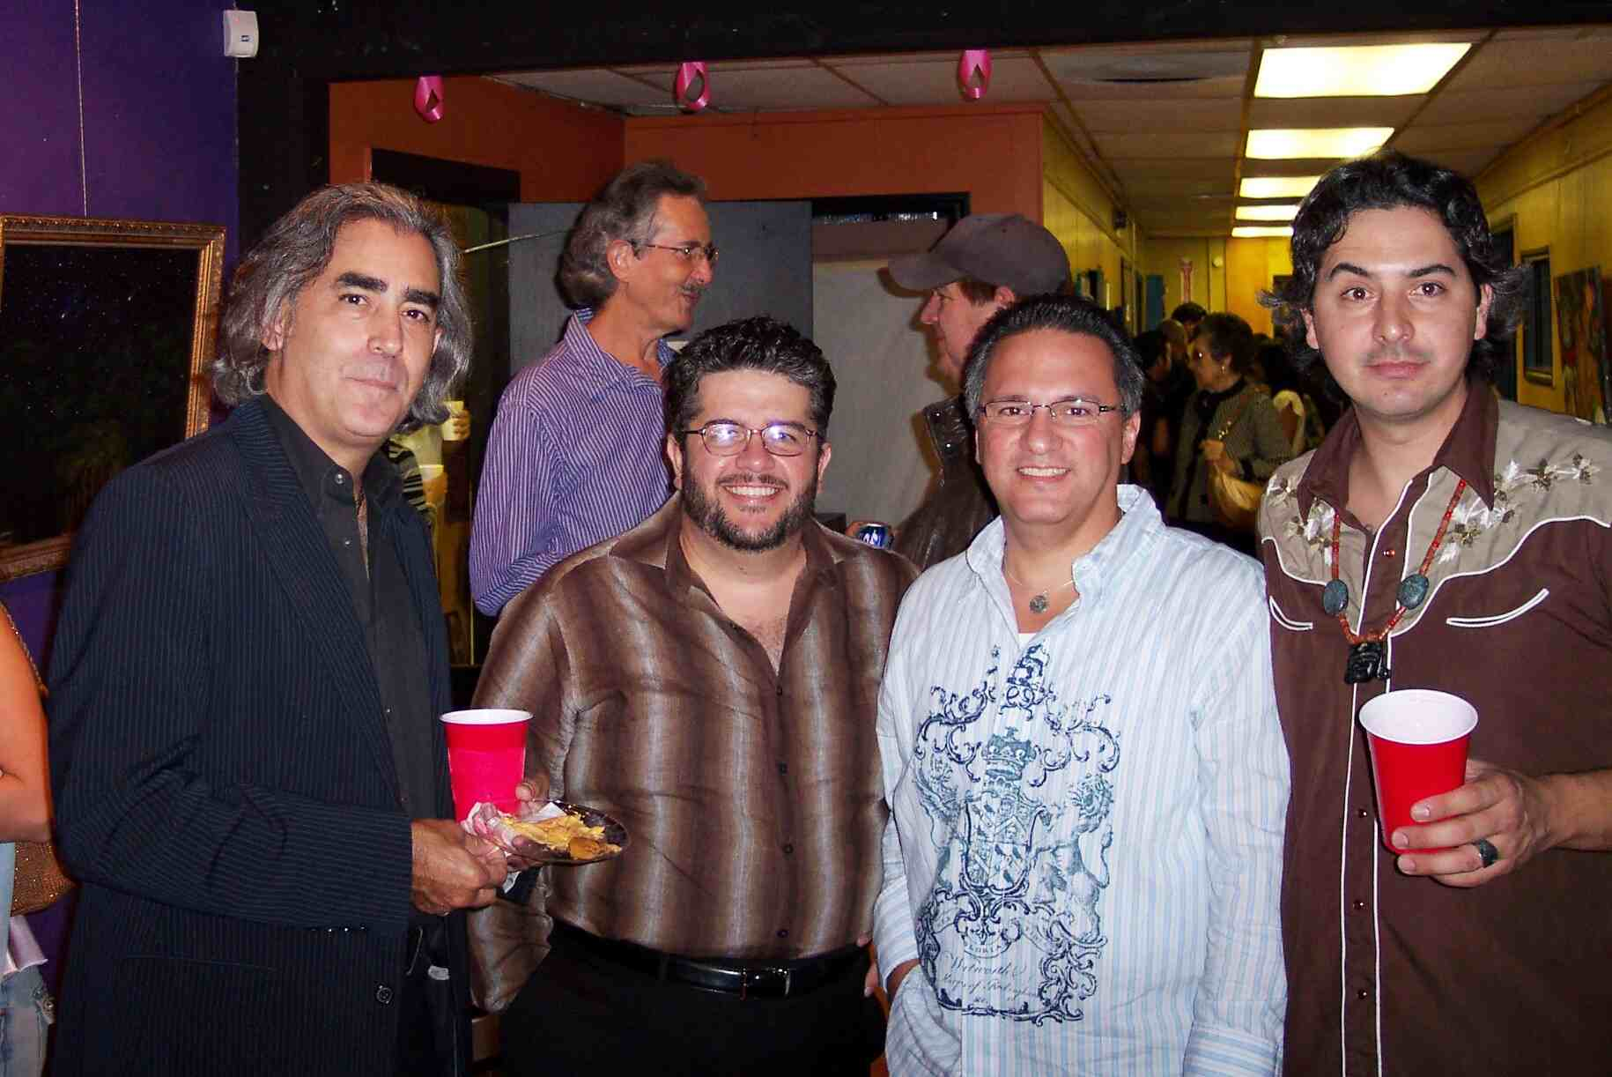
Writer John Phillip Santos, artists Daniel Guerrero, Arturo Almeida, Ricky Armendariz
There was a table set up with volunteers, Cynthia Spielman, Regina Chavez y Sanchez and Josie Martin, for Chican@ Art Magazine, which sold out of the premier issue of the magazine. Actor-Jessie Borrego, writer-John Phillip Santos<http://www.utsa.edu/lc/reading/santos.htm> , filmmakers-Laura Varela<http://www.nalip.org/LITI/2005/05_0524.htm> http://www.utsa.edu/today/2006/09/soundgallery.cfm , Guillermina Zabala <http://www.freewaves.org/artists/g_zabala/> , and Catherine Herrera, artists-Rolando Briseño, Angel Diaz, Victor Payan, and Ana Lilia Salinas were among some of the guests present... ...It was a full house in San Antonio, Tejaztlan...wish that you could have been here…
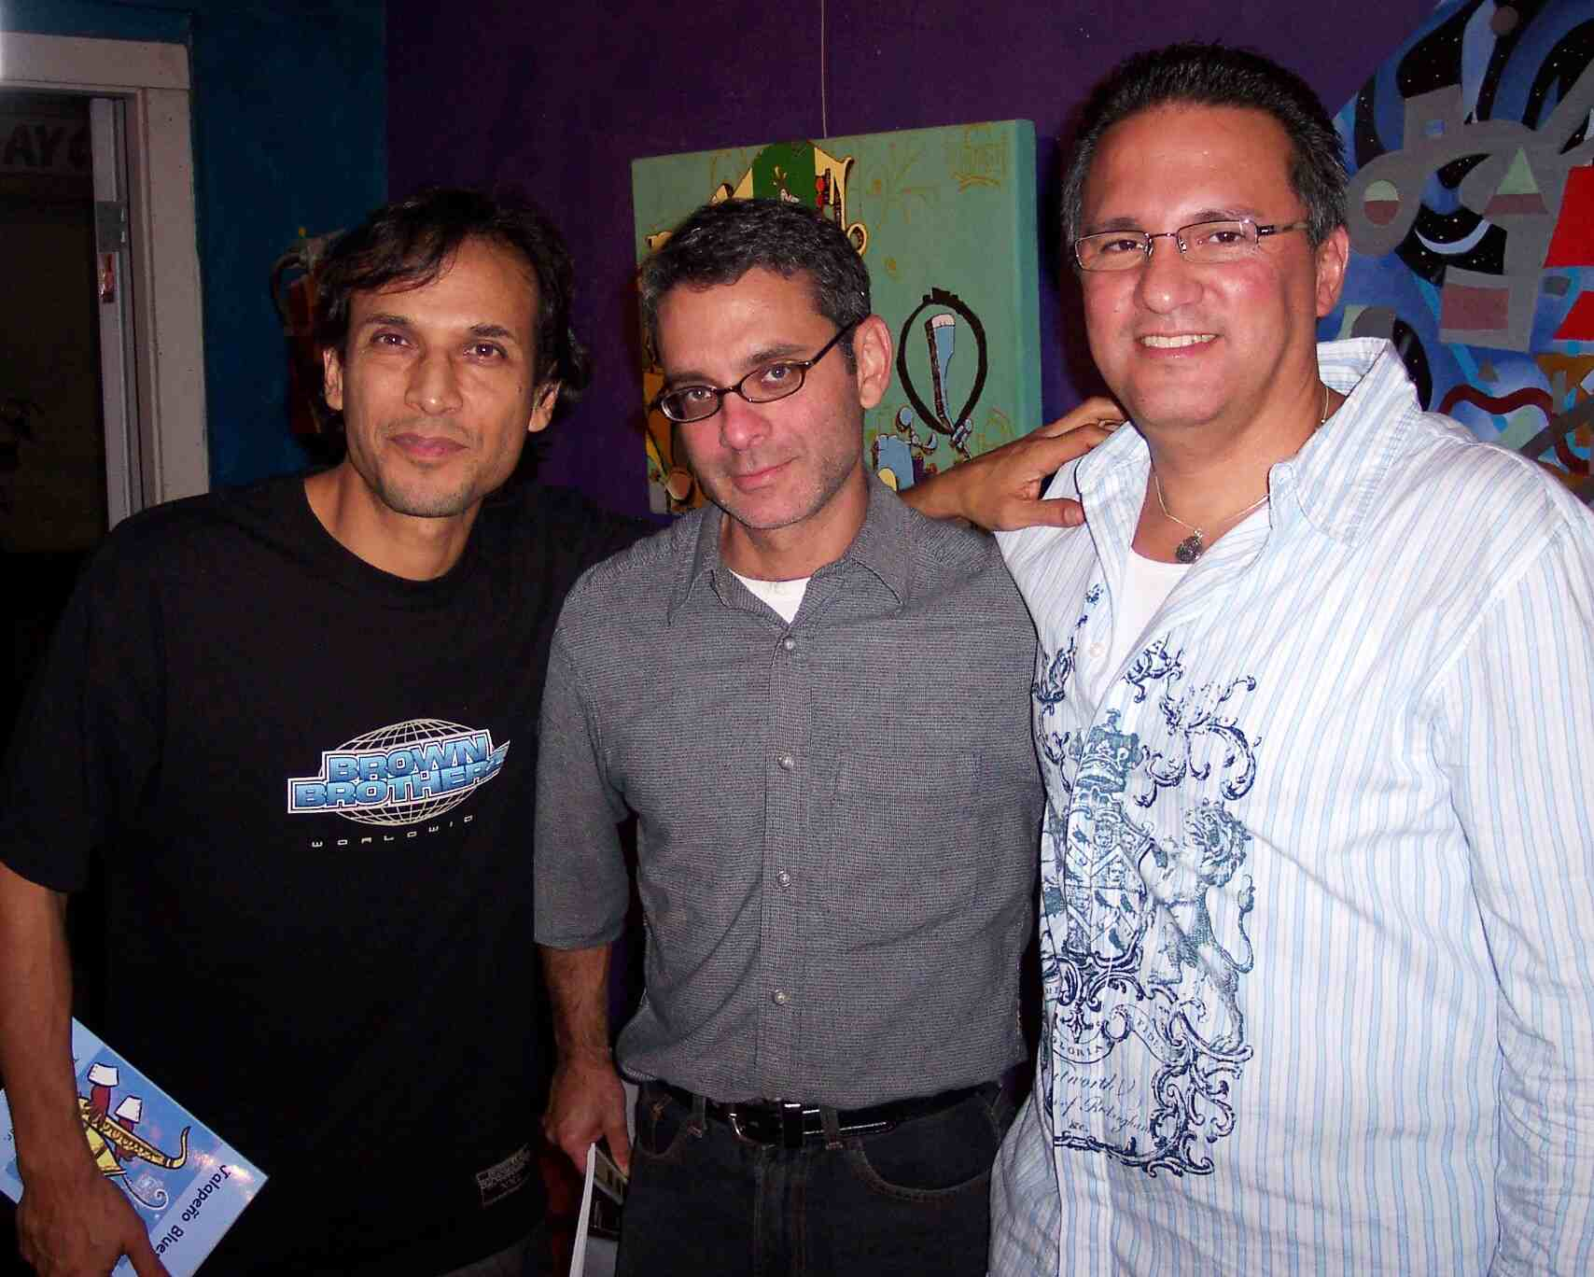
Actor Jesse Borrego, Scott Sherer UTSA -1604 Gallery Director, Arturo Almeida-UTSA Collection Curator
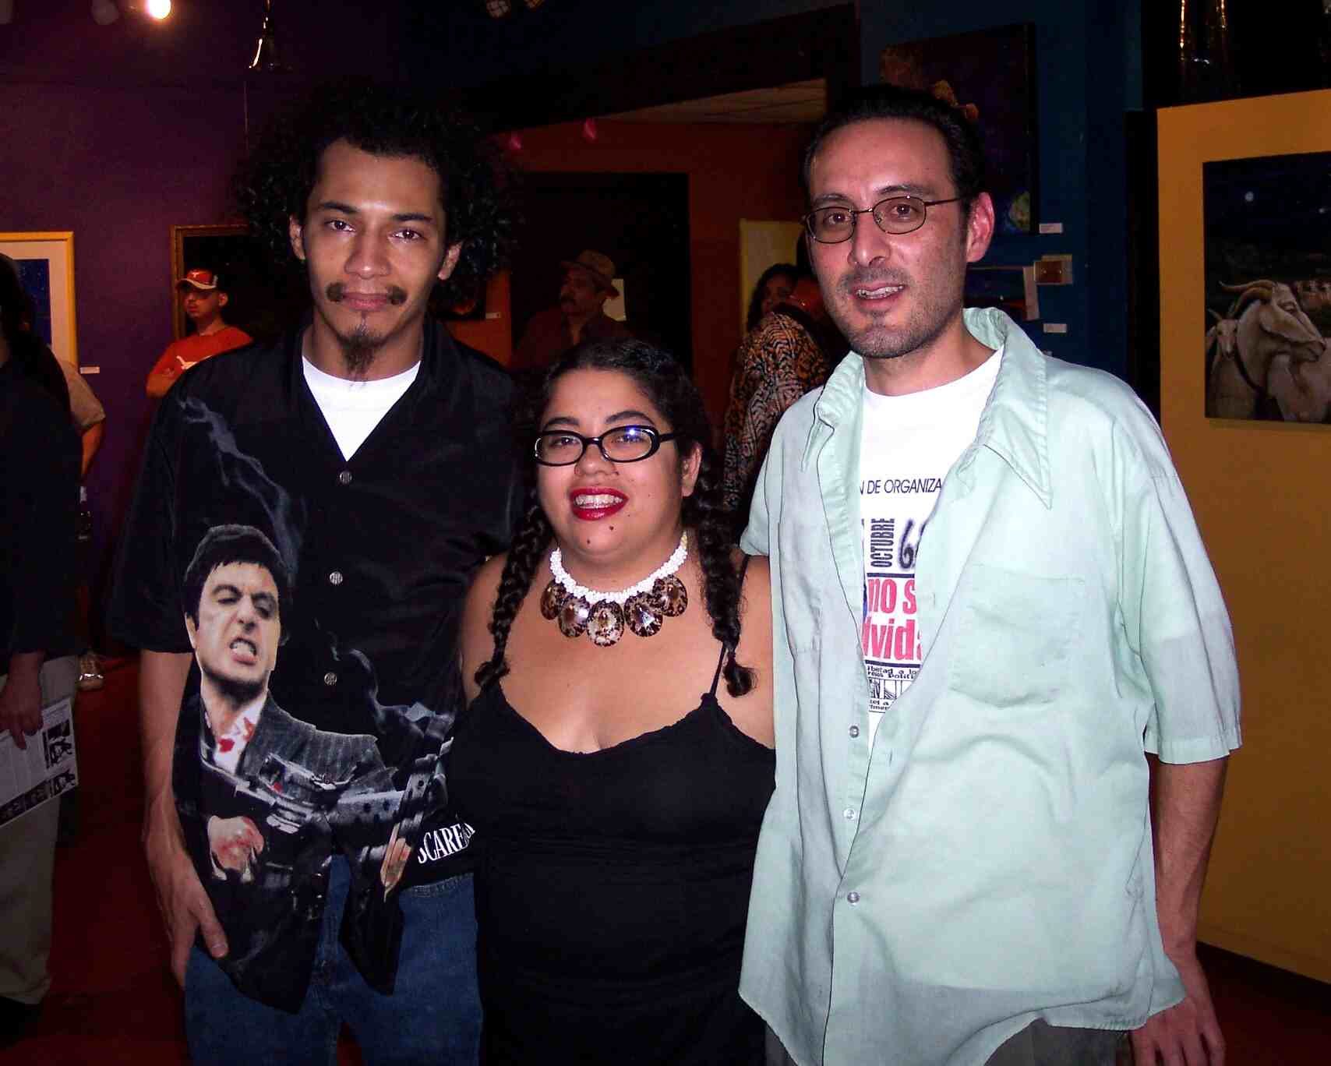
Artists Jose Cosme and Jane Madrigal & Rene Valdez-La Resistencia Bookstore

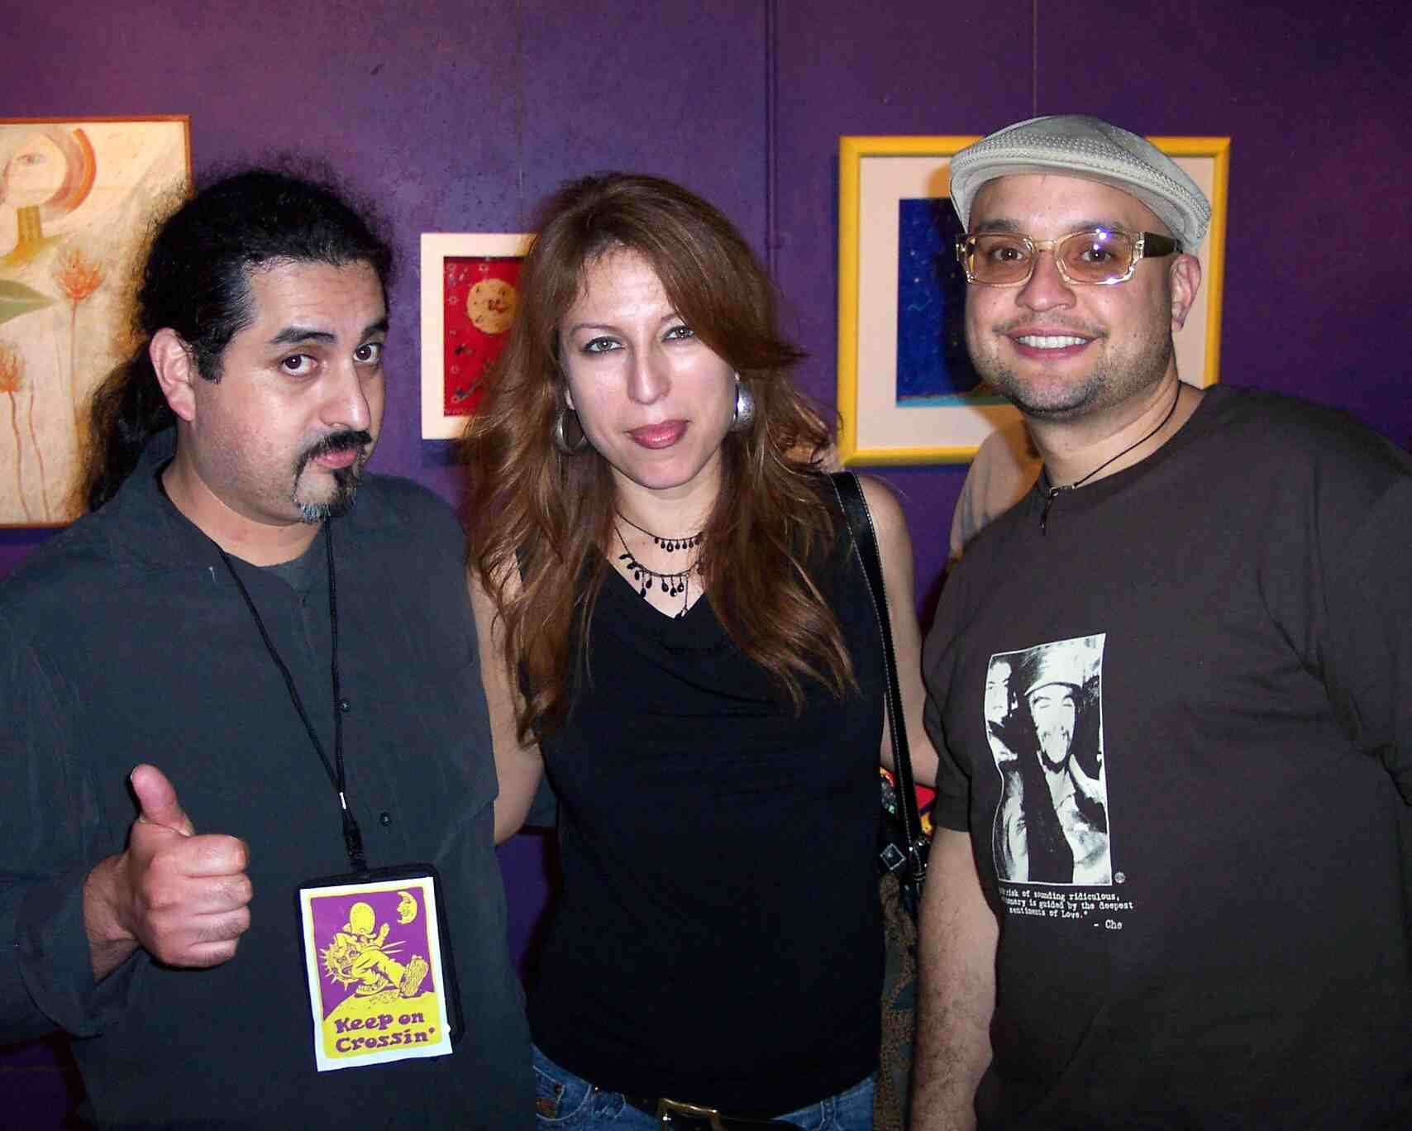
T's-Up from writer/producer Victor Payan, filmmaker Laura Varela, & Rafael Angel Zapata-Taller Portoriqueno in Philedelphia

Final List of participating artists ProjectMASA#2 10/18/06
Arturo Almeida, David Anaya, Ricky Armendariz, Andy Benavidez, Rob Benavidez, Magda Bowen, Rolando Briseño, Jesus ‘Chista’ Cantu, Jose Cosme, Ruben Cordova, Sam Coronado, L.A. David, Enrique Fernandez-Cervantes, Jose Esquivel, Carolina Flores, John Gallagher, Marie Garza, Xavier Garza, Angelica Gomez, Carlos Gomez, Quinton Gonzales, Ray Gonzales, Daniel Guerrero, Luis ‘Chispas” Guerrero, Jim Haught, Sergio Hernandez, Paul Karam, Joe Lopez, David Martinez, Jane Madrigal, Sandra A. Moreno, Victor Payan, Carlos Harrison-Pompa, Felipe Reyes, Mary Agnes Rodriquez, David Rice, Alberto Ramirez, C.A.S.A., Ana Lillia Salinas, Jose Segura, Raul Servin, Victor Tello, Lawrence Trujillo, Luis Valderas, debra kuetzpalin vasquez, Felipe Vasquez, Perry Vasquez, Gabriel Quintero-Velasquez, David Zamora-Casa
Filmmakers Laura Varela and Gullermina Zabala

Artists Luis ‘Chispas’ Guerrero & Victor Tello.

Artists Ana Lilla Salinas and debora kuetzpalin vasquez.

